**Lesson3 APP15:**

**Create an IAM Role**

Creating an IAM role

* In the IAM panel, click on *Roles* -> *Create role*

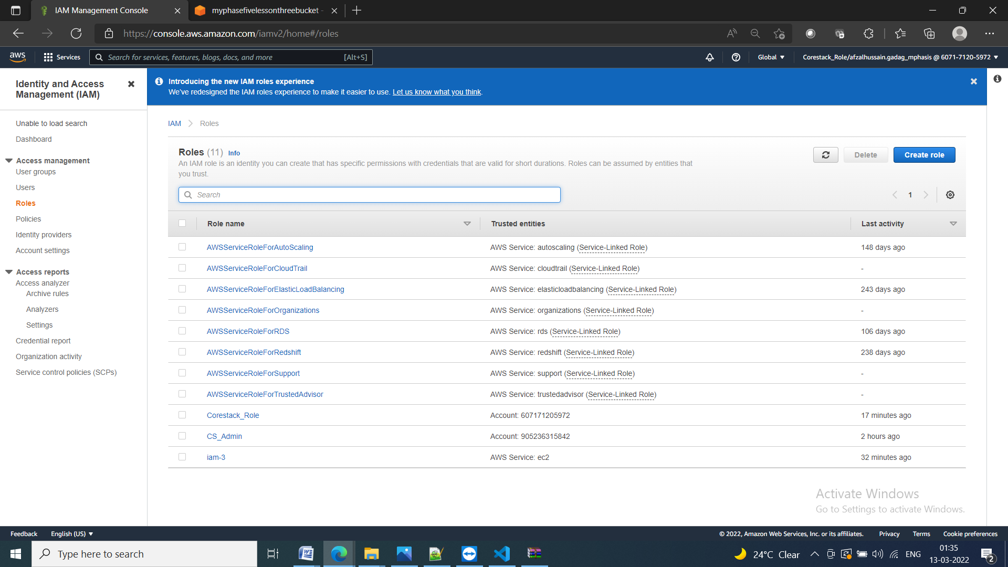

* Select the service

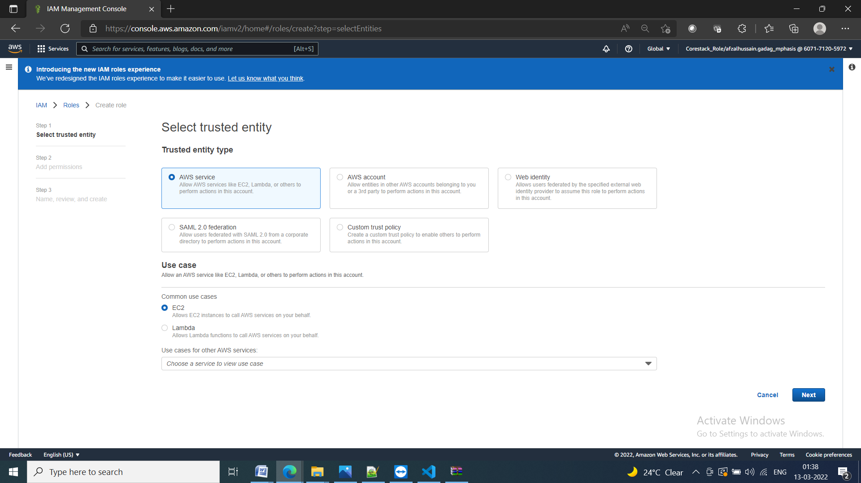

Adding AWS policy to the role

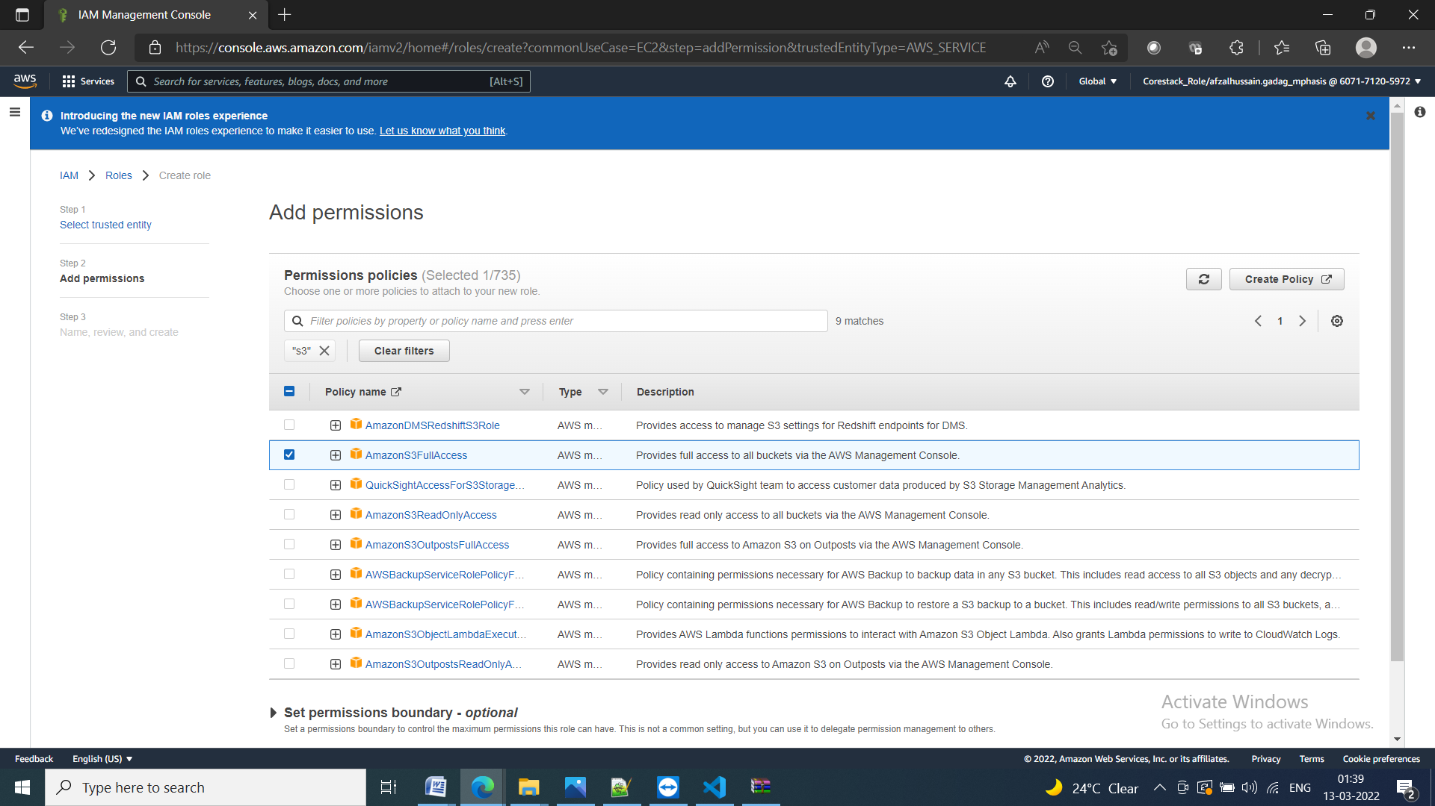

**Providing a key and a value for the role**

* Add a key and a value to the role

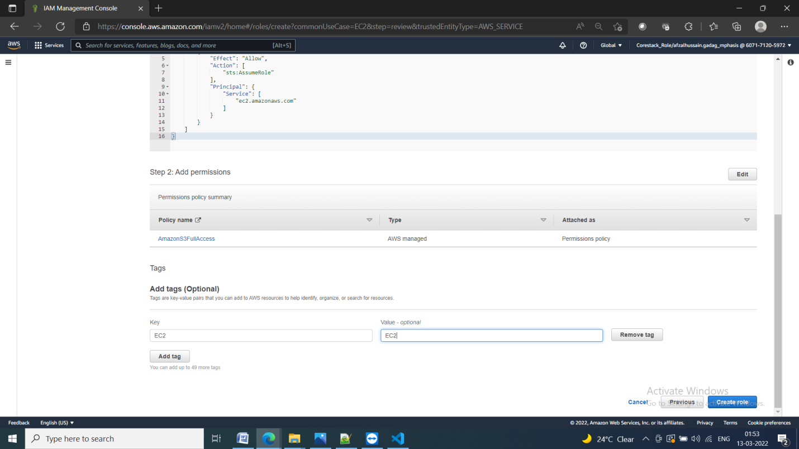

Add role name

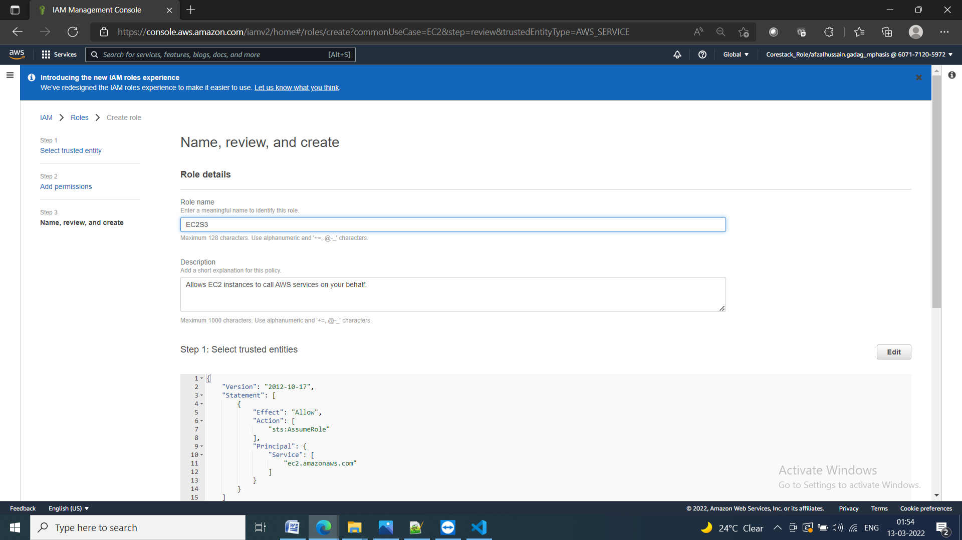

Role is created and we can check it in the AIM cosole

